|  |  |
| --- | --- |
| C:\Users\gps329\AppData\Local\Microsoft\Windows\INetCache\Content.MSO\5499F650.tmp | **Price Promotions Exercise** |
| **Marketing Analytics**  **Fall 2022** |

Sonnier Seasoned Salt has historically been America’s top-selling brand of seasoned salt. For years, because of its dominant market position, Sonnier concentrated on stimulating demand among current customers. Sonnier Seasoned Salt is sold to retailers in cases of 24 16 ounce containers. The regular gross margin the company makes on each container is $1.55, *after* any trade discounts (i.e., $1.55 * 24 = $37.20 per case). The brand has done very little advertising, concentrating instead on price promotions.

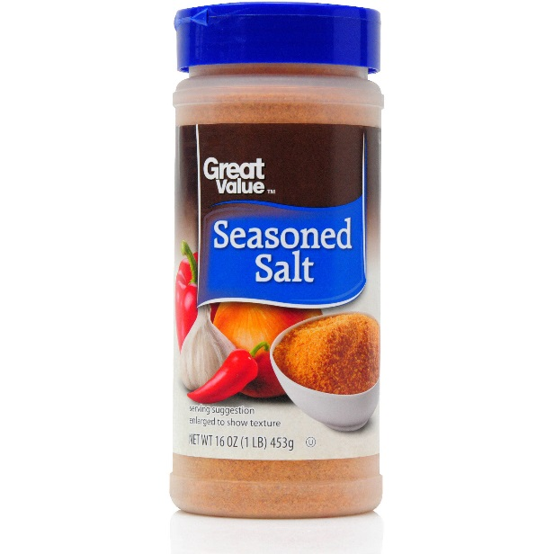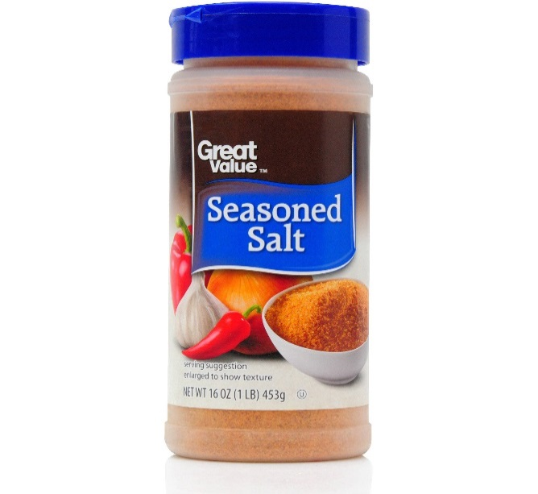

**Sonnier**

Price promotions have two components: a trade promotion in the form of a temporary price reduction to grocers, and a consumer promotion in the form of a coupon offering $1.00 off the purchase price of one 16 oz. container. The coupons are delivered via an “FSI” – a “Free Standing Insert” which is a booklet of coupons placed in local newspapers. In the face of falling newspaper subscription rates Sonnier Salt has also distributed coupons via its website since 2008. Consumers simply download and print the coupon and offer it for redemption at participating retailers. By late 2009, Sonnier Salt realized negligible download and redemption rates and thus in 2010 began spending on display advertising to drive traffic to the coupon webpage. Traffic on the websites served by the ad network largely consist of consumers who do not subscribe to newspapers and would otherwise be missed.

The Sonnier Seasoned Salt brand manager is considering options for price promotions for the month of January 2019.

**Trade Promotions for 2019:** The manager has already decided that she will freeze trade promotions so that all amounts in 2019 will be identical to the same month of 2018 (i.e. Jan 2019 will have the same trade promotion amount as Jan of 2018. Feb of 2019 will be the same as it was in Feb 2018).

**Consumer Promotions for 2019:** She is still considering whether to offer a **consumer promotion** during the month of January, 2019. The plan under consideration is to distribute coupons via national newspapers and the company website.

In terms of the newspaper distribution, 2 million coupons of $1.00 face value would be distributed in two of the five Sundays in January 2019 (Jan 13 and Jan 27) via a free standing insert into local market newspapers nationwide. Each coupon is valid towards $1.00 off the retail purchase price of one 16 oz. container of Sturdy Seasoned Salt. Based on past research, the manager knows that on average 10% of the coupons are redeemed. Printing and distribution costs for the coupons are $15 per thousand coupons. Coupon processing costs are 10 cents per redeemed coupon.

In terms of web distribution, Sonnier’s will place display ads on a network of websites that sell display ads on a cost-per-impression (CPM) basis. The ads are designed to drive traffic to the Sonnier’s webpage with the coupon where consumers can download the coupon for printing. The average cost-per-thousand impressions is $0.60. As with the newspaper each coupon is valid towards $1.00 off the retail purchase price of one 16 oz. container of Sonnier Seasoned Salt. The managerial goal is to generate 100MM impressions for the month. Historically the impressions generate a click rate of 4% for a total of 4MM site visits for the month. Again, based on past experience the manager expects the number of redeemed website coupons are 10% of the total site visits resulting from the display campaign. Organic and direct traffic is negligible and can be ignored for our purposes. The company also does not spend on paid search ads on Google. Regardless of the coupon source Sonnier must also reimburse the retailer the $1.00 whenever a coupon is used to make a purchase and also pays the $0.10 processing fee.

**The Decision**

The manager has data from the last few years (see data set) in which Sonnier’s has offered different consumer and trade promotions and seen various levels of sales.

* + The sales variable indicates the number of cases sold in that period.
  + The Consumer Promotion variable indicates the total dollar amount of redeemed coupons by consumers in that period. It does not differentiate between newspaper and web coupons. **It also does not include advertising, printing or processing costs,** which must be considered when assessing overall profitability. Since coupons have a face value of $1.00 this variable can also be thought of as the number of coupons that were redeemed in that period.
  + The Trade Promotion variable represents dealer allowances that include co-op advertising, display allowances, slotting allowances, etc. that were used in that period.

**Use the data set sonnier salt data student 2022.XLS and answer the following questions.**

1. **What is the cost of this promotion?**
2. **What are incremental sales (in cases) that must be achieved to break-even on this promotion?**
3. **Use the data to build a regression model of sales as a function of consumer and trade promotions (i.e., sales as the y variable; consumer promotions and trade promotions as the two X variables). What do you conclude about the effect of promotions on sales?**
4. **Consider other factors that might explain sales. How might you include seasonality factors, time trends or other dynamics into your model?**
5. **How might your model capture promotion dynamics?**
6. **How will the consumer promotion impact profits?**
7. **Should Sonnier go ahead with the promotion?**